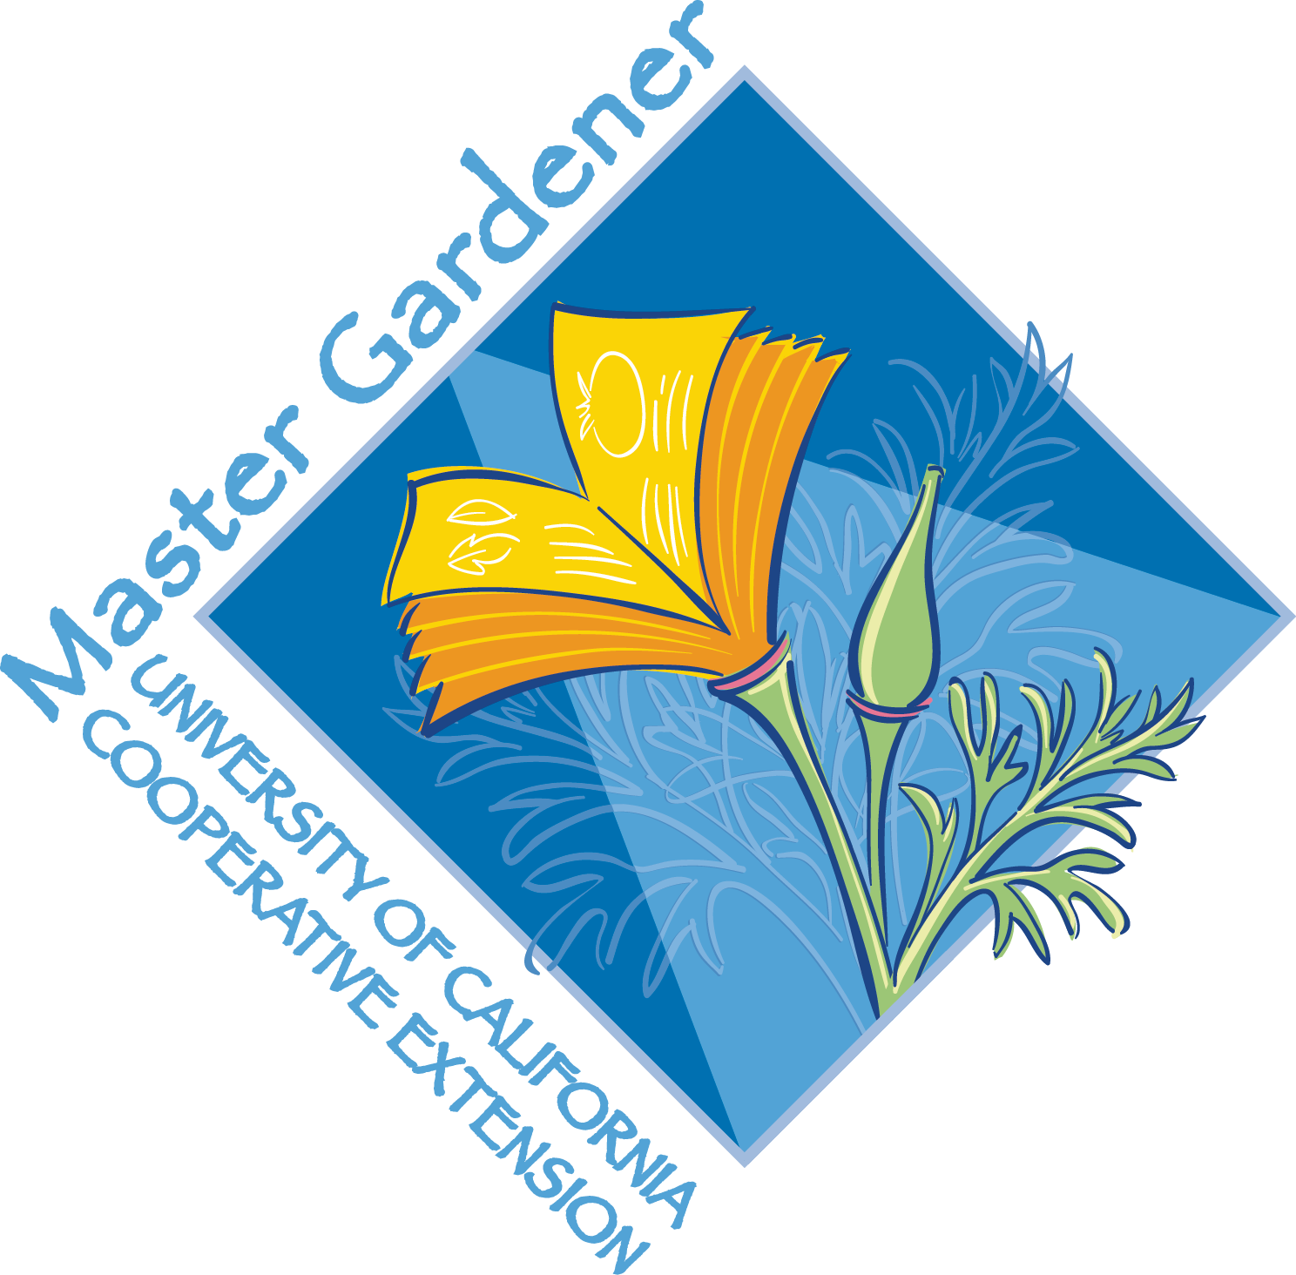
University of California (UC)
San Joaquin County Master Gardener Program
2017 Volunteer Application Form

UC Master Gardener Program Mission Statement
To extend research based knowledge and information on home horticulture, pest management, and sustainable landscape practices to the residents of California and be guided by our core values and strategic initiatives.

Instructions
Please complete all pages of the application.
A resume or cover letter may be attached; please do not attach any other supplemental material. The application and attachments will not be returned. (Pictures or other information may be brought to the interview.)
Applications must be received by October 14th, 2016. Please allow at least two weeks after the application closing date for a reply.

Personal Information

Legal Name
First and Last

Preferred Name
First and Last

Home Address
Number and Street, City, State, Zip

Phone Numbers
(Circle Type) Home, Cell, Work Home. Cell, Work

E-mail Address
(Required)

Best Contact Method and Time

Race/Ethnicity
(Optional)

Current Employment Status
(Double-click on check boxes and use the resulting menu to either check or uncheck.)
Full Time Retired/Unemployed
Part Time (hours/week: ) Seeking Employment

Do you have employment (including former employment) or education related to horticulture? Please explain:
(Text boxes will expand to accommodate longer answers, if filled out electronically. Double click inside the text box to begin typing.)

Volunteer and Other Experience and Interests

Please describe your volunteer experience (not just in gardening) within the past five years in the community.

Clubs, organizations, and other community-related affiliations:

When are you available to volunteer?

Other Information
List any languages, other than English, you speak and/or write fluently.

How did you hear about the UC Master Gardener Program?
Newspaper:
Gardening club or organization:
Current or past UC Master Gardener:
Farmers’ market:
UC Master Gardener newsletter

Have you ever applied to another UC Master Gardener Program? Yes No
If yes, what state and county?

Please review the following UC Master Gardener Program requirements and policies and indicate your acceptance of each by initialing the appropriate boxes.
Statements and Terms of Acceptance
I understand that, if accepted into the UC San Joaquin County Master Gardener Training Program, I will:
Pay a non-refundable training fee of $180.00, which includes class training materials, textbooks, and supplies. (A limited number of scholarships based upon financial need are available upon request, through consultation with the UC Master Gardener Program Coordinator.)

Submit to and pay for background screening and fingerprinting with a local law enforcement agency upon acceptance into the training program. (Fingerprinting applications will be sent with program acceptance forms and will be an out of pocket expense.)

I understand that I will become a certified UC Master Gardener only after I:
Attend all mandatory weekly training sessions, which will be held every Wednesday from January 25 through May 31, 8:30 a.m. to 1:30 p.m.

Complete and submit all homework assignments and quizzes, complete the final examination with a score of 70 percent or better and complete and pass the final project.

Agree to follow University of California policies and procedures while acting as a UC San Joaquin County Master Gardener.

I understand that I must do the following in order to maintain my
UC Master Gardener certification:
During the initial fiscal year (July 1, 2017 through June 30, 2018): Complete and record a minimum of fifty (50) hours of University of California Cooperative Extension (UCCE) sponsored volunteer service—including at least 6 hours at the UC Master Gardener Help Desk.

During subsequent fiscal years: Complete a minimum of twenty-five (25) hours of UCCE sponsored volunteer service and earn twelve (12) hours of continuing education credit through approved educations programs.

Signature Date

Please Return This Application To
Master Gardener Program, UC Cooperative Extension
2101 E. Earhart Avenue, Suite 200
Stockton, CA 95206
Applications must be received by October 14, 2016
Disclaimers

In compliance with the California Information Practices Act of 1977, the following information is provided: The information on this form is being requested by the University of California Cooperative Extension for use in the Master Gardener Program. The individual completing this form may make inquiries concerning use of the information collected and may ask to review the form as well as other non-confidential personal information maintained on record by contacting the local UCCE county director, the Master Gardener Advisor or County Program Coordinator or the statewide Academic Coordinator for the Master Gardener Program at: Missy Gable-Statewide Master Gardener Program, University of California, 2801 Second Street, Davis, CA 95618.

Information on this form is being requested under the authority of the Smith-Lever Act of 1914 covering Cooperative Extension activities and Article Ix, Section 9 of the State of California Constitution covering the University of California. Ethnic information is requested to maintain compliance with Title VI of the civil Rights Act of 1964 and sex information is requested to maintain compliance with Title IX of the Education Amendments of 1972. Statistical information on this form is being collected to satisfy the U.S. Department of Agriculture Extension Service reporting requirements for Affirmative Action and the Federal Affirmative Action Program Report. Statistical information includes sex, ethnic information and residence location. Submission of the above noted information is voluntary and if the information is not submitted by the source, the county master gardener staff may use his or her judgment to complete the information and satisfy Federal reporting requirements. Other personal information on this form is being collected to provide the County Extension Master Gardener staff with information to assist in program planning. This information consists of name, address, phone and email in addition to your skill set assessment.

The University of California prohibits discrimination or harassment of any person on the basis of race, color, national origin, religion, sex, gender, gender expression, gender identity, pregnancy, physical or mental disability, medical condition (cancer-related or genetic characteristics), genetic information (including family medical history), ancestry, marital status, age, sexual orientation, citizenship, or service in the uniformed services as defined by the Uniformed Services Employment and Reemployment Rights Act of 1994 (USERRA), as well as state military and naval service. Inquires regarding the University’s non-discrimination policies may be directed to the Affirmative Action/Staff Personnel Services Director, University of California Agriculture and Natural Resources, 1111 Franklin St. 6th floor, Oakland, CA 94607-5200, phone: (510) 987-0097

University policy is intended to be consistent with the provisions of applicable state and federal laws

